Call for B-Heritage Ambassadors: Join the 2nd "Dong-A WORLD" Project!

Are you interested in history, cultural exchange, and making new friends? Seokdang Museum of Dong-A University is looking for passionate international students to join the 2nd "Dong-A WORLD" Pre-Educator Project!
❓ What is Dong-A WORLD?
It’s a collaborative project where Korean and international students at Dong-A University will form teams (2 Korean students + 1 International student) to create fun, multi-language educational materials. Together, you will compare Dong-A University's cultural artifacts with the heritage from your home country.

🌍 What exactly will we do in this project?
As a B-Heritage Ambassador, you will work in a team with Korean students to create comparative cultural education materials.
- The Task: Your team will choose one cultural artifact from Dong-A University’s Museum and compare it with a similar artifact from your home country.
- The Output & Teaching Activity: You will create an Educational PPT and a Fun Workbook (with activities like coloring, matching games, etc.). Starting around July, you will actually use these materials to teach elementary students or multicultural families as a Field Educator-and you will receive a separate teaching fee of at least 40,000 KRW per session.
- The Goal: After completing the program, you can use these materials to actually teach children or multicultural families in the global and local community!

🤝 Team Formation & Language Barrier
- Team Structure: Each team will have 2 Korean students and 1 International student.
- "I don't have a team!" 👉 No problem! You can apply as an individual, and we will match you with friendly Korean teammates during the 2nd session. If you already have Korean friends you want to work with, write your "Team Name" on the application.
- "My Korean isn't perfect!" 👉 That is 100% okay! The main goal is cross-cultural communication. You can use translation apps, English, and body language. Sharing your home country's culture is your most important role!
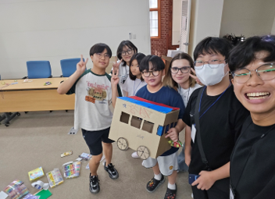 | 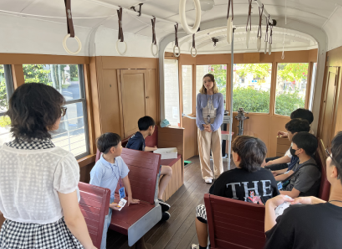 | 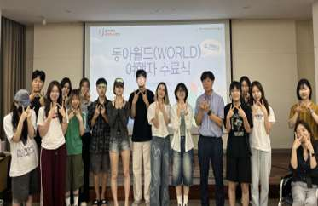

📅 Program Overview
- Activity Period: April 4 (Sat) ~ July 17 (Fri), 2026
- Format: Total 12 sessions (24 hours), including special lectures, museum practicals, and team workshops.
 | Timeline | Category | Details | Instructor
1 | Apr.04.(Sat)  10:00~12:00  (2hrs) | Orientation | ① Intro to the Dong-A WORLD project  ② Mission: The Secret of the Red Bricks (ENG)  ③ ICE-BREAKING | Museum Staffs
2 | Apr.11.(Sat)  10:00~12:00  (2hrs) | Museum Practical I | ① Intro to the potential artifacts from the museum  ② Guideline meeting for heritage education  ③ Team formation | Museum Staffs
3 | Apr.17.(Fri)  13:00~15:00  (2hrs) | Special Lecture I | ① Cultural Heritage Interpretation & Digital Curation (KOR & ENG) | Lyndsey  Twining  (Academy of Korean Studies)
4 | May.02.(Sat)  10:00~12:00  (2hrs) | General Workshop I | ① Practice writing comparative cultural education contents  ② Guide on making lesson plans | Museum Staffs
5 | Once in May  (2hrs) | Team Workshop I | ① Presentation and feedback on team lesson plans  ② Team career counseling and capacity-building | Museum Staffs
6 | May.22.(Fri)  13:00~15:00  (2hrs) | Special Lecture II | ① Yeongnam Journey: The "Hip-Han" Scholar's Way of Travel (KOR) | Lee Seong-hun  (Museum Curator of Busan City)
7 | May.29.(Fri)  10:00~12:00  (2hrs) | Museum Practical II | ① Feedback on team drafts and lesson plans  ② "Museum X Meet" Art Workshop (Clay Soap) | Museum Staffs
8 | Jun.5.(Fri)  10:00~12:00  (2hrs) | General Workshop II | ① Guide to Object-Based Learning (OBL) cultural heritage education  ② Team teaching simulation presentations and advising | Kim Eun-jeong (Heritage Educator)
9  10  11 | 3 times in Jun~Jul  (6 hrs) | General Workshop III  Team Workshop II, III | ① Team teaching simulation presentations and advising  ② Final submission of heritage education contents | Kim Eun-jeong  Museum Staffs
12 | Jul.17.(Fri)  15:00~17:00  (2hrs) | Completion Ceremony | ① Awarding of certificates ② Satisfaction survey  ③ Guide to Field Educator Activities (after July) | Museum Staffs

🎁 Awesome Benefits
- Official Certificate from the Director of Dong-A University Museum (requires attendance at 11+ sessions)
- DECO Points: 12 points
- Student Activity Scholarships
⚠️ Note: The exact amount will be announced during the interview.
- Paid Teaching Opportunity: Field Educator for the local community (paid 40,000+ KRW per session)
- 1365 Volunteer Hours: Up to 24 hours

✅ Who Can Apply? (Eligibility)
- All enrolled undergraduate students at Dong-A University. (Any major, any year, and International Students are highly welcome!)
⚠️ Important Note on Scholarships: Students on a leave of absence, delaying graduation, exchange students, and language school students are welcome to participate, but please note that you are not eligible for the student activity scholarship due to university rules. However, you will still receive the official certificate and volunteer hours!

🎯 What We Are Looking For (Requirements)
- A strong interest in Museum, World Heritage, and cultural diversity education.
- A great sense of responsibility and volunteer spirit! You must be committed to completing the entire schedule without dropping out.
- Willingness to participate in "Field Educator Activities" (teaching elementary students or multicultural families) after completing the program.

🌟 How to Apply
- Application Period: March 16 (Mon) ~ March 29 (Sun), 2026, by 23:59
- Where to Apply: email to museum@dau.ac.kr
- Submission: Download the application forms, fill them out, and combine them into ONE single PDF file.
- File Name Format: StudentID_Name.pdf (e.g. 1234567_Jane.pdf)

 |  |  |  |  | Receipt No. |  |  | Please leave this blank
The 2nd “Dong-A WORLD”: Pre-Educator Project
APPLICATION FORM
Personal Information | NAME |  |  |  |  | Student ID
Personal Information | Major/Dept. |  |  |  |  | Nationality
Personal Information | E-mail |  |  |  |  | Mobile Number
Personal Information | Team Name  (Fill out ONLY  If applying as a team) |  |  |  |  | Team members  (Stu. ID & Name)
Extracurricular Activities
Please list your major activities over the past 3 years (e.g., clubs, volunteering, awards, part-time jobs, etc.)
Period |  |  | Activity Name |  | Organization |  | Descriptions |  | Active?
2026.03. | - | 2026.08. | Part-time jobs |  | Dong-A Market |  | Selling Dong-A goods |  | O/X
2026.03. | - | 2026.12.
SNS Accounts  (e.g., instagram, Facebook, etc.) |  |  |  | Language ability |  |  |  | Software skills
Please write your ID |  |  |  | KOREAN TOPIK 5  English, Vietnamese |  |  |  | (e.g., Canva, Premiere Pro, Photoshop, PowerPoint, etc.)
We’d love a follow: @dongamuseum
Self-introduction and Motivation to apply
I agree to comply with all guidelines of the <2nd Dong-A WORLD Pre-Educator Project>
and hereby submit this application.

Participant Name : (signature)

